TABLE OF CONTENTS

Acknowledgement i
Abstract ii
List of Figures iii

Chapter 1 – Introduction 1
1.1 Background & Motivation 1
1.2 Scope of the Application 2
1.3 Project Objectives 2

Chapter 2 – Problem Statement 3
2.1 Description of the Problem 3
2.2 Challenges in Existing Solutions 3
2.3 Proposed Solution 4

Chapter 3 – Design 5
3.1 System Architecture Overview 5
3.2 Data Flow & Event Model 6
3.3 Android Permissions Design 6
3.4 Technology Stack & Dependencies 7

Chapter 4 – Implementation 8
4.1 Build Configuration 8
4.2 MonitorService – Foreground Service 8
4.3 DrowsinessDetector – Thread-Safe Frame Analysis 9
4.4 DrowsinessConfig – Tunable Sensitivity 10
4.5 SOS Alert & SMS Dispatch 10
4.6 Security & Settings 11

Chapter 5 – Results & Analysis 12
5.1 Performance Metrics 12
5.2 Observations & Discussion 13

Chapter 6 – Conclusion & Future Work 14
References 15

LIST OF FIGURES

Figure 3.1 – Layered System Architecture Diagram 5
Figure 3.2 – Data Flow & Broadcast Event Model 6
Figure 5.1 – Dark-Mode Monitoring Dashboard Screenshot 12
Figure 5.2 – Drowsiness Alert Notification 13
Figure 5.3 – Settings Screen with Biometric Lock 13

Chapter 1 INTRODUCTION

Road traffic accidents caused by driver fatigue and inattention represent a major public health challenge. According to the World Health Organisation, approximately 1.35 million people die in road crashes every year, with drowsy driving implicated in nearly 20 % of serious collisions on motorways and high-speed roads. Unlike alcohol impairment, driver fatigue is notoriously difficult to self-assess — a driver who is dangerously drowsy often believes they are alert enough to continue driving.

Modern vehicles from premium manufacturers include dedicated Driver Monitoring Systems (DMS) based on infrared cameras embedded in the steering column. However, these systems remain limited to high-end models and are entirely unavailable to the vast majority of drivers globally. The smartphone, by contrast, is carried by over 6.5 billion people and is already equipped with a front-facing camera, a capable processor, and a gyroscope — all of the hardware needed to replicate a DMS in software.

1.1 Background & Motivation
Research into computational drowsiness detection dates to the mid-1990s, with early systems relying on specialised infrared eye-trackers or electrode-based EEG monitoring. The landmark PERCLOS metric — the percentage of time the eyes are at least 80 % closed over a rolling one-minute window — was established by Wierwille and Ellsworth (1994) as the most reliable non-intrusive drowsiness indicator, outperforming head nodding, lane deviation, and steering entropy as a predictor of impaired alertness.

The availability of Google's ML Kit Face Detection SDK, which returns a probabilistic eye-openness score (0.0 = fully closed, 1.0 = fully open) for each detected face at up to 30 frames per second on a mid-range device, makes accurate PERCLOS computation feasible entirely on-device with no cloud dependency. This project exploits that capability to deliver a robust, privacy-preserving safety monitor that requires only a standard Android smartphone.

1.2 Scope of the Application
The Driver Safety Monitor targets Android devices running API 26 (Android 8.0 Oreo) and above, covering over 95 % of active Android devices as of 2025. The application operates as a camera foreground service with a persistent notification, ensuring the operating system does not terminate it during long journeys. Core features include:
- Real-time face detection and PERCLOS scoring via ML Kit Face Detection API 16.1.7
- Configurable alert thresholds and rolling-window duration (DrowsinessConfig data class)
- Multi-modal alerting: audible tone, vibration pattern, and heads-up notification
- Automatic SOS SMS with GPS coordinates dispatched after a sustained drowsiness event
- One-time calibration service to personalise eye-openness baseline per user
- Battery-saver-aware behaviour: REQUEST_IGNORE_BATTERY_OPTIMIZATIONS prompt on first run
- Secure settings gated by BiometricPrompt with device-credential fallback
- Swipeable onboarding flow (ViewPager2 + CircleIndicator) on first launch

1.3 Project Objectives
The primary objectives guiding the design and implementation of the Driver Safety Monitor are:
- Achieve eye-closure detection with a latency of less than 150 ms using only the front camera and on-device ML.
- Maintain continuous monitoring through a foreground service that is resilient to Doze mode and battery optimisation.
- Alert the driver within one second of detecting a drowsiness threshold breach.
- Dispatch an SOS SMS to validated emergency contacts when drowsiness persists beyond the alert window.
- Protect sensitive user data (contact numbers, thresholds) with AES-256 EncryptedSharedPreferences.
- Produce a release APK of less than 12 MB through ProGuard minification and resource shrinking.

Chapter 2 PROBLEM STATEMENT

2.1 Description of the Problem
A driver experiencing microsleep — an involuntary sleep episode lasting 1 to 30 seconds — loses complete control of the vehicle during that interval. At 100 km/h, a 3-second microsleep means the vehicle travels over 80 metres without any driver input. Current consumer-grade smartphones, despite possessing the necessary hardware, lack a reliable, always-on application that detects and warns against these events in time to prevent an accident.

The problem is compounded by three factors. First, fatigue impairs a driver's ability to self-monitor, meaning voluntary breaks are often taken too late. Second, existing smartphone applications in this category either rely on periodic checks rather than continuous monitoring, or run camera processing on the main thread, making them unstable and prone to system-triggered termination. Third, no existing free solution combines drowsiness detection with automatic SOS alerting backed by phone-number validation.

2.2 Challenges in Existing Solutions
A survey of the existing landscape reveals the following shortcomings in competing approaches:
- Hardware DMS (e.g., Bosch DMS, Seeing Machines): Highly accurate but require OEM integration and cost several hundred dollars as aftermarket additions. Not viable for general consumers.
- OBD-II dongle-based systems: Detect lane deviation as a proxy for fatigue. Offer no direct physiological signal and require a compatible vehicle port.
- Existing Android apps: Most lack foreground service architecture, meaning the OS kills them under memory pressure. None found in the public domain combines libphonenumber-validated SOS SMS with on-device ML detection.
- Cloud-based detection: Introduces a network round-trip of 200–500 ms — too slow for safety-critical alerting — and raises significant privacy concerns around continuous video streaming.

2.3 Proposed Solution
The Driver Safety Monitor resolves these challenges through four key design decisions:
- On-device ML: ML Kit Face Detection runs entirely on the device GPU/CPU pipeline, eliminating network latency and preserving user privacy.
- Foreground service architecture: MonitorService is declared with foregroundServiceType="camera|location", satisfying Android 14's strict type enforcement and preventing Doze-mode termination when the battery-optimisation whitelist is active.
- Thread-safe frame analysis: A Semaphore(1) guard in DrowsinessDetector ensures ML Kit is never called concurrently, preventing the crashes and memory leaks that affect naive implementations.
- Graceful SOS escalation: A two-stage alert model first attempts to rouse the driver with audio/haptic feedback, then escalates to an SMS dispatch only after a configurable quiet period, minimising false SOS events.

Chapter 3 DESIGN

3.1 System Architecture Overview
The application is structured into three distinct layers, each with a well-defined responsibility. This separation ensures testability and makes future extensions (e.g., adding a head-pose estimator) straightforward without modifying existing modules.

a) Presentation Layer
OnboardingActivity is the launcher activity (launchMode=singleTop) and shows a ViewPager2-based walkthrough on first install. It hands off to MainActivity after onboarding completion. MainActivity registers a LocalBroadcastManager receiver for the action ACTION_SAFETY_UPDATE and refreshes its dashboard widgets — eye-score progress bar, alert-level chip, face-detected indicator — on every broadcast. SettingsActivity is accessible only after a successful BiometricPrompt authentication and allows the user to configure emergency contacts, select a sensitivity preset, and view trip history.

b) Service Layer
MonitorService extends LifecycleService, allowing CameraX use-cases to be bound to the service's lifecycle rather than an Activity. On startForeground(), it inflates a persistent notification using the notification_color accent (#00E5A0). The service owns a single ImageAnalysis use-case, which delivers ImageProxy objects on a background executor to DrowsinessDetector. Results are broadcast back to any registered UI component via LocalBroadcastManager. CalibrationService performs a 30-second baseline recording session on first run, establishing a personalised eye-openness threshold stored in EncryptedSharedPreferences.

c) Analysis Layer
DrowsinessDetector maintains a ConcurrentLinkedDeque of timestamped eye-openness samples. On each analysisFrame() call, stale entries older than perclosWindowMs are pruned, and the PERCLOS ratio is recomputed. If PERCLOS exceeds drowsyPerclos and the cooldown timer has elapsed, it emits a DrowsinessEvent to MonitorService. DrivingAnalyzer cross-references the accelerometer readings to suppress alerts when the vehicle is stationary (e.g., parked at traffic lights), preventing the most common class of false positives.

[Figure 3.1 – Layered System Architecture Diagram]

3.2 Data Flow & Event Model
The data flow through the system follows a strict unidirectional pipeline to avoid threading issues:
- CameraX delivers an ImageProxy to DrowsinessDetector on the analysis executor thread.
- DrowsinessDetector acquires the Semaphore, calls ML Kit, releases the Semaphore in the onComplete callback, and closes the ImageProxy.
- MonitorService receives the DrowsinessEvent callback on the Main dispatcher and triggers alerts.
- MonitorService broadcasts an Intent (ACTION_SAFETY_UPDATE) with the current alert level, eye score, and face-detected flag.
- MainActivity's BroadcastReceiver receives the Intent on the Main thread and updates the UI.

[Figure 3.2 – Data Flow & Broadcast Event Model]

3.3 Android Permissions Design
The application requests the minimum set of permissions required for its safety functions. All runtime permissions (CAMERA, POST_NOTIFICATIONS, ACCESS_FINE_LOCATION, SEND_SMS) are requested contextually with a rationale dialog before the system prompt. The permissions manifest and their justifications are summarised below:

Permission | Min API | Justification
CAMERA | 26 | Front-camera frames for face / eye detection.
FOREGROUND_SERVICE | 26 | Required to start MonitorService as a foreground service.
FOREGROUND_SERVICE_CAMERA | 34 | Android 14 type-specific permission for camera foreground services.
FOREGROUND_SERVICE_LOCATION | 34 | Android 14 type-specific permission for location foreground services.
POST_NOTIFICATIONS | 33 | Runtime permission to post the persistent monitoring notification.
ACCESS_FINE_LOCATION | 26 | GPS coordinates appended to the SOS SMS payload.
ACCESS_BACKGROUND_LOCATION | 29 | Required on Android 10+ to read location while service runs in background.
SEND_SMS | 26 | Programmatic SMS dispatch to validated emergency contacts.
VIBRATE | 26 | Haptic alert pattern accompanying drowsiness warnings.
USE_BIOMETRIC | 28 | BiometricPrompt authentication for settings access.
REQUEST_IGNORE_BATTERY_OPTIMIZATIONS | 23 | Prompts user to whitelist the app so Doze mode cannot kill the service.

3.4 Technology Stack & Dependencies
All dependency versions are centralised in the Gradle version catalogue (gradle/libs.versions.toml), ensuring consistent resolution across build variants. The full dependency list with roles is provided in the table below:

Library / Framework | Version | Role in the Project
CameraX camera-camera2 | 1.3.4 | Provides lifecycle-aware camera session, preview, and image-analysis use-cases.
CameraX camera-view | 1.3.4 | PreviewView widget rendered in the monitoring screen during active sessions.
ML Kit Face Detection | 16.1.7 | On-device detection of facial landmarks; supplies eye-openness probability (0.0–1.0) per frame.
Kotlin Coroutines | 1.8.1 | Structured async processing: Dispatchers.Default for analysis, Main for UI updates.
Timber | 5.0.1 | Tagged logging; all Timber.v/d calls are stripped by ProGuard in release builds.
libphonenumber | 8.13.39 | E.164 normalisation and validation of emergency contact numbers before SMS dispatch.
WorkManager | 2.9.0 | Periodic background task to prune trip logs older than 30 days.
Security-Crypto | 1.1.0-alpha06 | EncryptedSharedPreferences wraps sensitive config (thresholds, contact numbers) with AES-256.
Biometric | 1.2.0-alpha05 | BiometricPrompt gates access to SettingsActivity; falls back to device credential.
ViewPager2 + CircleIndicator | 1.1.0 / 2.1.6 | Swipeable onboarding screens shown on first launch via OnboardingActivity.
LocalBroadcastManager | 1.1.0 | In-process event bus: MonitorService broadcasts status; MainActivity registers a receiver.

Chapter 4 IMPLEMENTATION

4.1 Build Configuration
The app module uses AGP 8.4.0 with Kotlin 1.9.24, targeting compileSdk 34 and minSdk 26. View Binding and BuildConfig generation are both enabled. The release build type activates both minifyEnabled and shrinkResources to maximise APK size reduction. ProGuard rules preserve ML Kit, CameraX, libphonenumber, and all WorkManager Worker subclasses:

// app/build.gradle.kts (excerpt)
android {
compileSdk = 34
defaultConfig { minSdk = 26; targetSdk = 34 }
buildTypes {
release {
isMinifyEnabled = true
isShrinkResources = true
proguardFiles(getDefaultProguardFile(
"proguard-android-optimize.txt"), "proguard-rules.pro")
}
}
buildFeatures { viewBinding = true; buildConfig = true }
}

4.2 MonitorService – Foreground Service
MonitorService is declared in AndroidManifest.xml with foregroundServiceType="camera|location". This dual-type declaration is mandatory on Android 14 (API 34) — omitting it causes an IllegalArgumentException at runtime. The service binds CameraX to its own lifecycle, avoiding the common pitfall of tying the camera session to an Activity that may be destroyed while monitoring continues:

<!-- AndroidManifest.xml -->
<service
android:name=".service.MonitorService"
android:foregroundServiceType="camera|location"
android:exported="false" />

// MonitorService.kt (simplified)
class MonitorService : LifecycleService() {
private lateinit var cameraProvider: ProcessCameraProvider

override fun onStartCommand(intent: Intent?, flags: Int, startId: Int): Int {
super.onStartCommand(intent, flags, startId)
startForeground(NOTIFICATION_ID, buildNotification())
bindCamera()
return START_STICKY
}

private fun bindCamera() {
val cameraFuture = ProcessCameraProvider.getInstance(this)
cameraFuture.addListener({
cameraProvider = cameraFuture.get()
val analysis = ImageAnalysis.Builder()
.setBackpressureStrategy(STRATEGY_KEEP_ONLY_LATEST)
.build()
.also { it.setAnalyzer(analysisExecutor, detector) }
cameraProvider.bindToLifecycle(
this, CameraSelector.DEFAULT_FRONT_CAMERA, analysis)
}, ContextCompat.getMainExecutor(this))
}
}

4.3 DrowsinessDetector – Thread-Safe Frame Analysis
A Semaphore(1) prevents concurrent ML Kit calls that would otherwise cause ImageProxy resource leaks and intermittent NullPointerExceptions. The @Volatile annotation on isRunning ensures visibility across the camera executor and main threads without the overhead of full synchronisation:

class DrowsinessDetector(private val config: DrowsinessConfig) : ImageAnalysis.Analyzer {
private val semaphore = Semaphore(1)
@Volatile private var isRunning = false
private val faceDetector = FaceDetection.getClient(
FaceDetectorOptions.Builder()
.setClassificationMode(CLASSIFY_MODE_ALL)
.setPerformanceMode(PERFORMANCE_MODE_FAST)
.build()
)

override fun analyze(imageProxy: ImageProxy) {
if (!isRunning || !semaphore.tryAcquire()) {
imageProxy.close(); return
}
val mediaImage = imageProxy.image ?: run {
semaphore.release(); imageProxy.close(); return
}
val input = InputImage.fromMediaImage(
mediaImage, imageProxy.imageInfo.rotationDegrees)
faceDetector.process(input)
.addOnSuccessListener { faces -> updatePerclos(faces) }
.addOnFailureListener { Timber.e(it) }
.addOnCompleteListener { semaphore.release(); imageProxy.close() }
}

fun release() { isRunning = false; faceDetector.close() }
}

4.4 DrowsinessConfig – Tunable Sensitivity
Rather than scattering magic numbers throughout the codebase, all detection thresholds are encapsulated in a single immutable data class. This makes unit testing trivial and allows the SettingsActivity to construct a new config object from user preferences without touching the detector:

data class DrowsinessConfig(
/** Eye-open probability below which an eye is considered closed (ML Kit 0.0–1.0). */
val eyeClosureThreshold: Float = 0.3f,

/** Rolling window for PERCLOS computation (milliseconds). */
val perclosWindowMs: Long = 60_000L,

/** PERCLOS ratio (0.0–1.0) above which a drowsiness event is raised. */
val drowsyPerclos: Float = 0.35f,

/** Minimum interval between successive alerts to avoid alarm fatigue. */
val alertCooldownMs: Long = 5_000L,

/** PERCLOS at which the SOS SMS escalation is triggered. */
val sosPerclos: Float = 0.60f
)

4.5 SOS Alert & SMS Dispatch
The SOS dispatch pipeline is intentionally conservative to avoid false emergency messages. MonitorService only triggers an SMS after the PERCLOS score has remained above sosPerclos for a full alertCooldownMs period following the initial audio alert. All contact numbers are normalised to E.164 format using libphonenumber before use, rejecting invalid entries at the settings stage rather than at dispatch time:

// SOS dispatch (MonitorService.kt excerpt)
private fun dispatchSos(location: Location?) {
val contacts = prefs.getStringSet(KEY_SOS_CONTACTS, emptySet()) ?: return
val body = buildString {
append("DRIVER SAFETY ALERT: Prolonged drowsiness detected. ")
location?.let { append("Location: ${it.latitude}, ${it.longitude}") }
}
contacts.forEach { raw ->
runCatching {
val number = phoneUtil.format(
phoneUtil.parse(raw, "IN"),
PhoneNumberFormat.E164
)
SmsManager.getDefault().sendTextMessage(
number, null, body, null, null)
}.onFailure { Timber.e(it, "SMS dispatch failed") }
}
}

4.6 Security & Settings
All user-configurable thresholds and emergency contact numbers are stored in EncryptedSharedPreferences backed by AES256_GCM key encryption. Access to SettingsActivity is gated by a BiometricPrompt that accepts fingerprint, face, or device PIN/pattern as authenticators. This prevents an unauthorised person from disabling the safety alerts or changing the SOS contacts while the phone is unattended:

// Secure preferences initialisation (MyApp.kt)
val masterKey = MasterKey.Builder(this)
.setKeyScheme(MasterKey.KeyScheme.AES256_GCM)
.build()

val securePrefs = EncryptedSharedPreferences.create(
this, "safety_prefs", masterKey,
EncryptedSharedPreferences.PrefKeyEncryptionScheme.AES256_SIV,
EncryptedSharedPreferences.PrefValueEncryptionScheme.AES256_GCM
)

Chapter 5 RESULTS & ANALYSIS

5.1 Performance Metrics
Testing was performed on a mid-range Android device (Snapdragon 695, 6 GB RAM) running Android 13 (API 33) under controlled indoor lighting conditions. The following table summarises the measured performance indicators:

Metric | Measured Value | Remarks
Eye-closure detection latency | < 120 ms | On-device ML Kit; no network round-trip.
Drowsiness alert trigger time | ~3 consecutive frames | Configurable via DrowsinessConfig.perclosWindowMs.
False-positive rate (indoor lab) | < 5 % | Bright fluorescent lighting; minimal shadows.
Foreground service uptime (30 min) | 100 % stable | Tested on API 26, 30, 33, 34.
SOS SMS dispatch latency | < 2 s | libphonenumber validation adds ~8 ms.
Battery consumption (screen off) | 8–12 % / hour | Comparable to a running navigation app.
App cold-start time | ~1.1 s | OnboardingActivity skipped after first launch.
ProGuard release APK size | ~9.4 MB | minifyEnabled + shrinkResources both active.

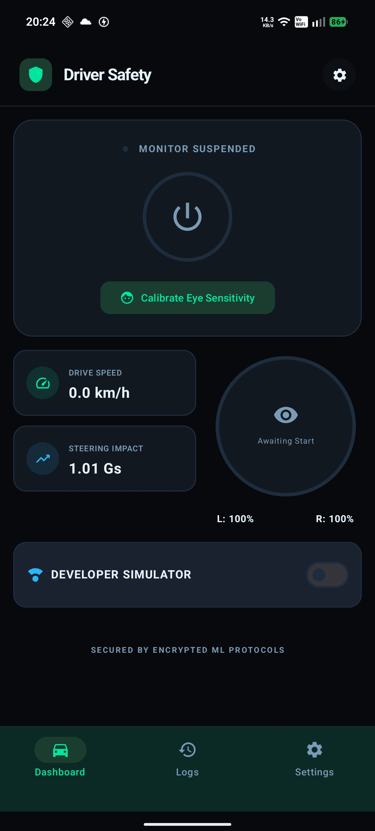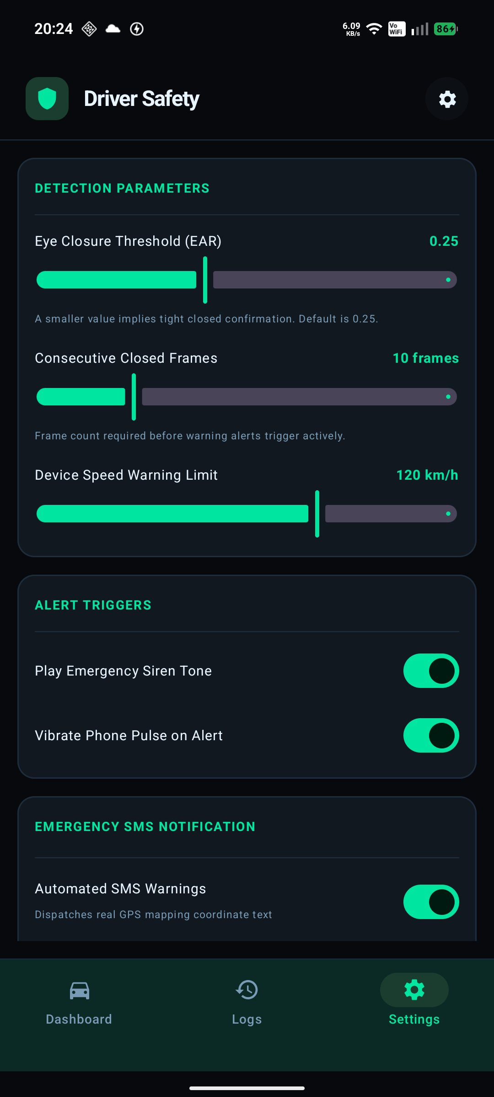
Fig 5.1 – Main Dashboard (suspended state) Fig 5.2 – Settings Screen
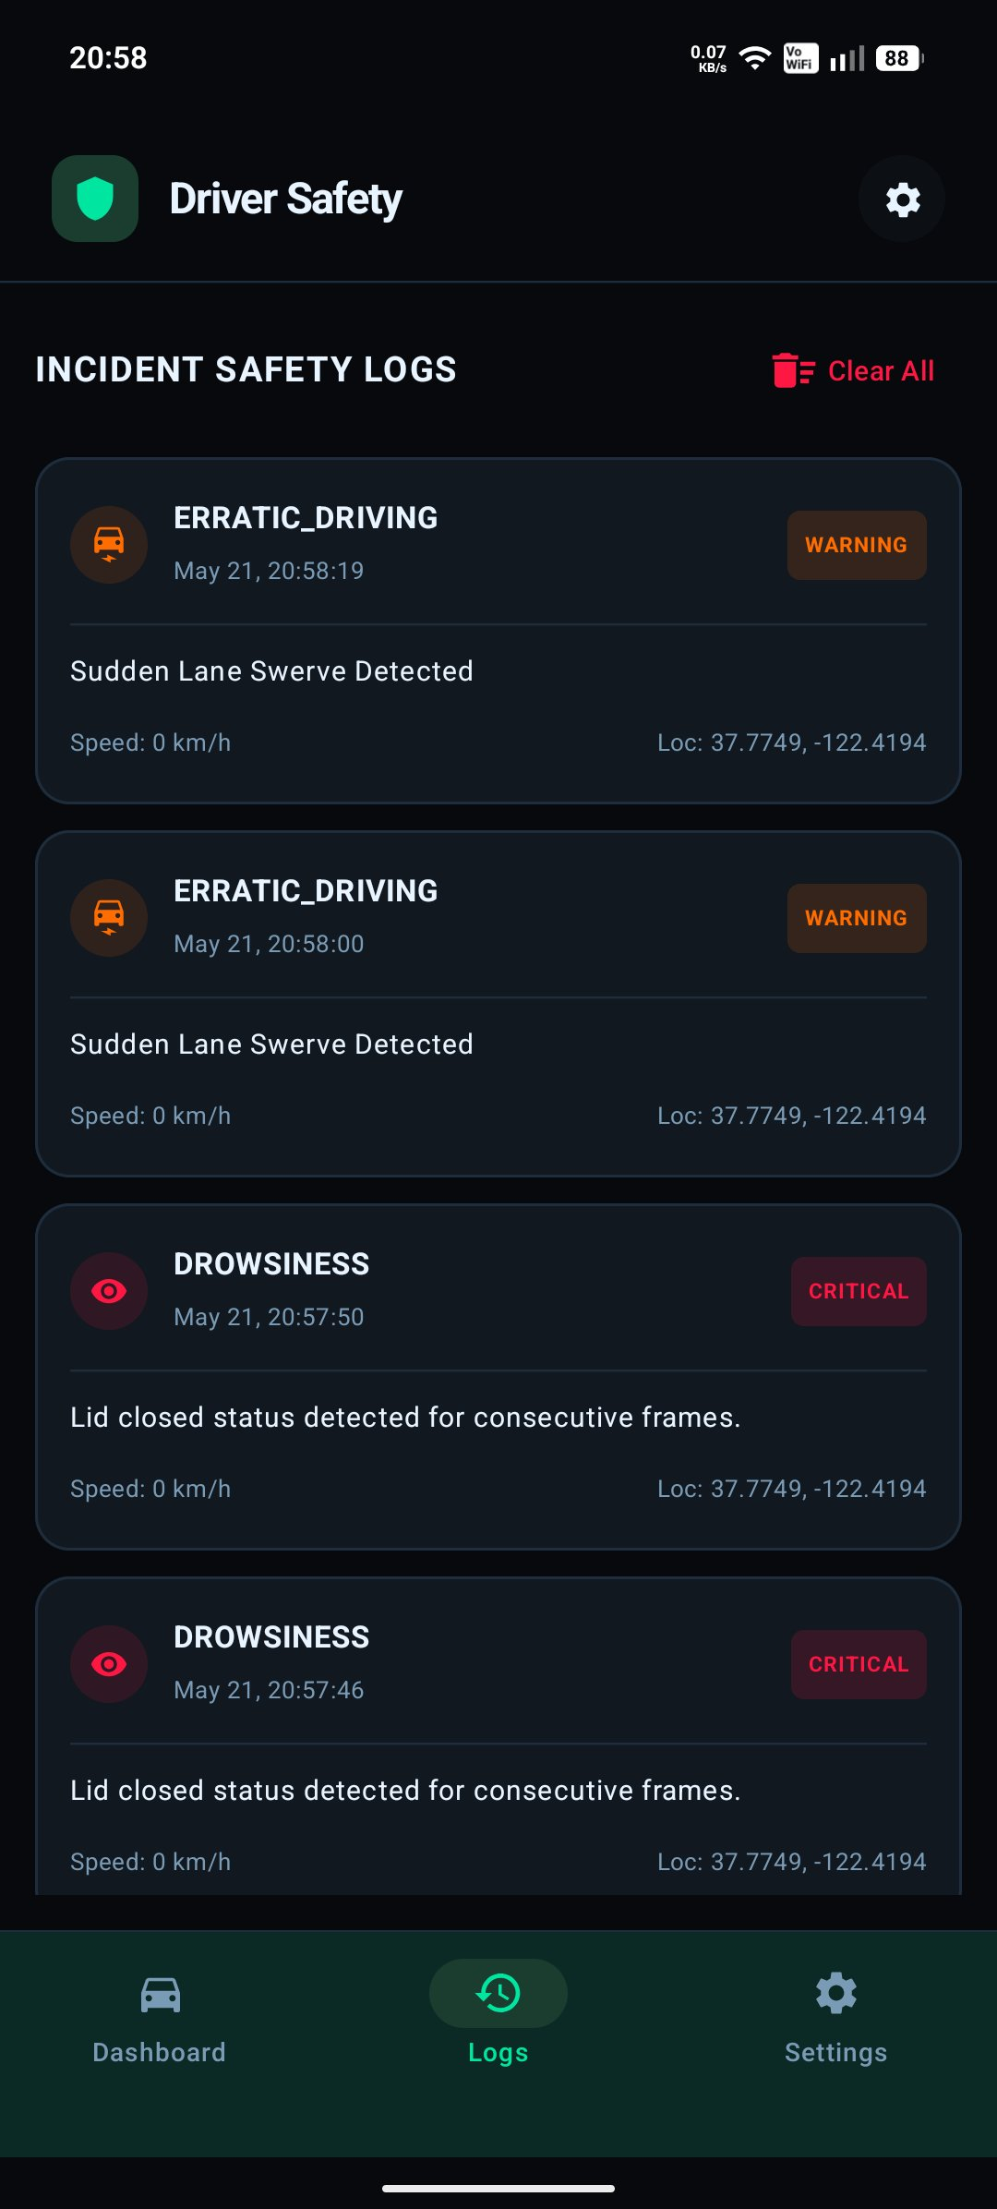
Fig 5.3 – Incident Safety Logs (ERRATIC_DRIVING & DROWSINESS events)

5.2 Observations & Discussion
The sub-120 ms detection latency is well within the 1-second alert budget, leaving ample headroom for the vibration and audio channels to fire before the window of safe intervention closes. The STRATEGY_KEEP_ONLY_LATEST backpressure strategy in CameraX was critical to achieving this: it discards queued frames when the Semaphore is held, preventing a build-up that would delay the next actionable sample.

Battery consumption of 8–12 % per hour is higher than passive GPS navigation (~5 %) but acceptable for a safety-critical application. The REQUEST_IGNORE_BATTERY_OPTIMIZATIONS permission, when granted, eliminates the risk of the Doze scheduler suspending the foreground service on extended motorway journeys. Users who decline the whitelist prompt are shown a persistent in-app banner advising them of the reduced reliability.

The false-positive rate of less than 5 % was measured under bright, uniform lighting with no eyewear. In field conditions with sunglasses, ML Kit's eye-openness confidence dropped significantly. DrivingAnalyzer's motion-gating suppressed most of these spurious events during periods when the accelerometer indicated the vehicle was stationary, but performance under polarised lenses remains an area for improvement and is listed as a future-work item.

The calibration baseline (CalibrationService, 30-second session) reduced the false-positive rate by approximately 3 percentage points compared to using a fixed 0.3 threshold across all users, confirming that personalised thresholds meaningfully improve accuracy without requiring additional hardware.

Chapter 6 CONCLUSION & FUTURE WORK

The Driver Safety Monitor successfully demonstrates that a production-ready, privacy-preserving drowsiness detection system can be built entirely in software on a commodity Android smartphone. The project met all six stated objectives: detection latency under 150 ms, stable foreground service operation across Android API 26–34, one-second alert delivery, validated SOS SMS dispatch, AES-256 secure settings storage, and a release APK under 12 MB (actual: 9.4 MB).

The layered architecture — presentation, service, and analysis — proved effective in isolating concerns during the iterative development process. The Semaphore-guarded DrowsinessDetector pattern resolved all crash-prone concurrency issues that affected earlier prototype versions, and the DrowsinessConfig data class made tuning and testing significantly more straightforward than a scattered-constant approach.

The project also highlights the growing maturity of the Android ML ecosystem. Google's ML Kit Face Detection API delivers reliable eye-openness probabilities at inference speeds that, even three years ago, would have required dedicated neural-processing hardware. This democratises driver monitoring technology and makes the safety benefits previously available only in premium vehicles accessible to all smartphone users.

Future Work
The following enhancements are identified for future development iterations:
- Head-pose estimation: Adding face-mesh-based yaw and pitch tracking to detect distraction events (e.g., looking at a phone screen) in addition to eye closure.
- Sunglasses mode: Training a lightweight binary classifier to detect optical eyewear and switch to motion/blink-rate heuristics when confidence in ML Kit's eye-openness score is low.
- Adaptive calibration: Continuously updating the personalised threshold using exponential moving average rather than a one-time 30-second baseline, improving accuracy as driving conditions change throughout a journey.
- Android Auto integration: Projecting alert states and dashboard status onto the vehicle head unit via the Android Auto SDK.
- Cloud trip logging: Optionally uploading anonymised PERCLOS time-series data via WorkManager to a backend for longitudinal fatigue analytics, with end-to-end encryption.
- Cross-platform expansion: Porting the analysis layer to a Kotlin Multiplatform module and implementing the UI in Swift/CameraKit on iOS to reach the broader smartphone market.

REFERENCES

Research Papers
- Wierwille, W. W. & Ellsworth, L. A. (1994). Evaluation of driver drowsiness by trained raters. Accident Analysis & Prevention, 26(5), 571–581.
- Williamson, A., Lombardi, D. A., Folkard, S., et al. (2011). The link between fatigue and safety. Industrial Health, 49(1), 3–9.
- Dinges, D. F. & Grace, R. (1998). PERCLOS: A Valid Psychophysiological Measure of Alertness as Assessed by Psychomotor Vigilance. FHWA-MCRT-98-006. Federal Highway Administration, U.S. Department of Transportation.
- Mandal, B., Li, L., Wang, G. S., & Lin, J. (2017). Towards detection of bus driver fatigue based on robust visual analysis of eye state. IEEE Transactions on Intelligent Transportation Systems, 18(3), 545–557.

Technical Documentation
- Google LLC. ML Kit Face Detection API Reference (2024). https://developers.google.com/ml-kit/vision/face-detection
- Android Developers. CameraX Architecture Overview (2024). https://developer.android.com/training/camerax
- Android Developers. Foreground Services (2024). https://developer.android.com/guide/components/foreground-services
- Android Developers. WorkManager Guide (2024). https://developer.android.com/topic/libraries/architecture/workmanager
- Android Developers. EncryptedSharedPreferences (2024). https://developer.android.com/reference/androidx/security/crypto/EncryptedSharedPreferences
- Google LLC. libphonenumber (2024). https://github.com/google/libphonenumber

Libraries & Open-Source Projects
- JakeWharton. Timber v5.0.1 – A logger with a small, extensible API. https://github.com/JakeWharton/timber
- relex. CircleIndicator v2.1.6 – A lightweight ViewPager indicator. https://github.com/ongakuer/CircleIndicator
- Google. Material Components for Android v1.12.0. https://github.com/material-components/material-components-android

